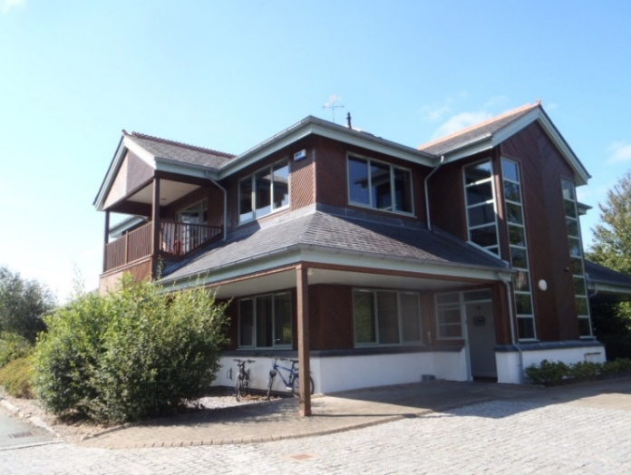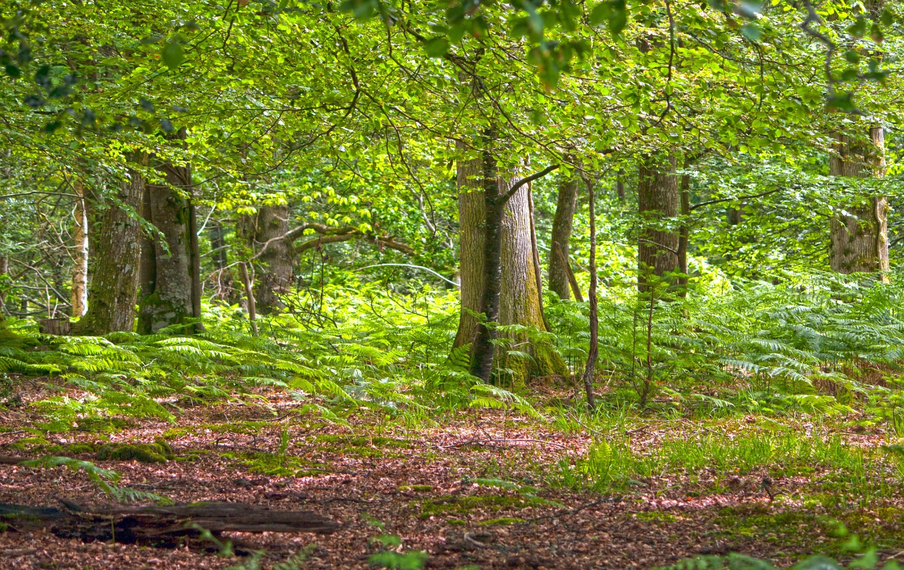

**PROSPECTUS**

The Forestry Hub is a shared, modern office space in the Dyfi Eco Parc in Machynlleth. Located by the railway station, the Forestry Hub offers good transport links to mid, west and north Wales.

The Welsh Government subsidises the Forestry Hub to enable a range of Welsh woodland and forestry organisations to work closely together to support forestry sector priorities.

**The Forestry Hub**

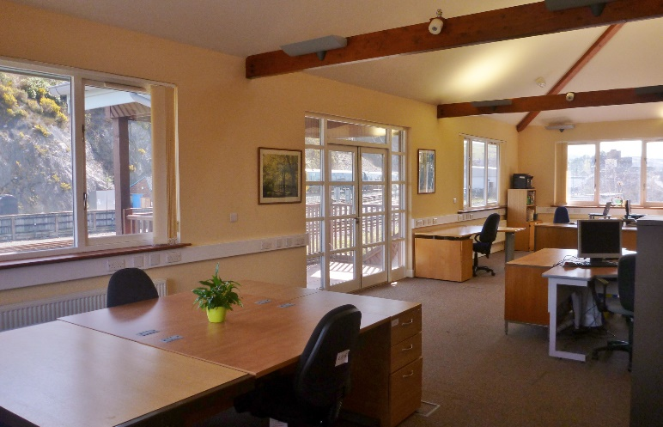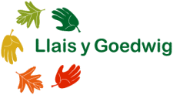

***Are you looking for a modern work space that helps you deliver your work and connects you with others in the woodland sector?***

**Located on the first floor of a Dyfi Eco Parc energy efficient building. The forestry hub can offer you:**

* Opportunities for permanent and hot desks
* Furnished open-plan shared office space
* Meeting room for up to 20 people
* 24-hour access and security
* Car parking and lift access
* Wi-Fi, telephones and answerphone
* High quality printer, photocopier and scanner
* Kitchen and toilet facilities
* Located next to the railway station
* Fantastic views of nearby woods

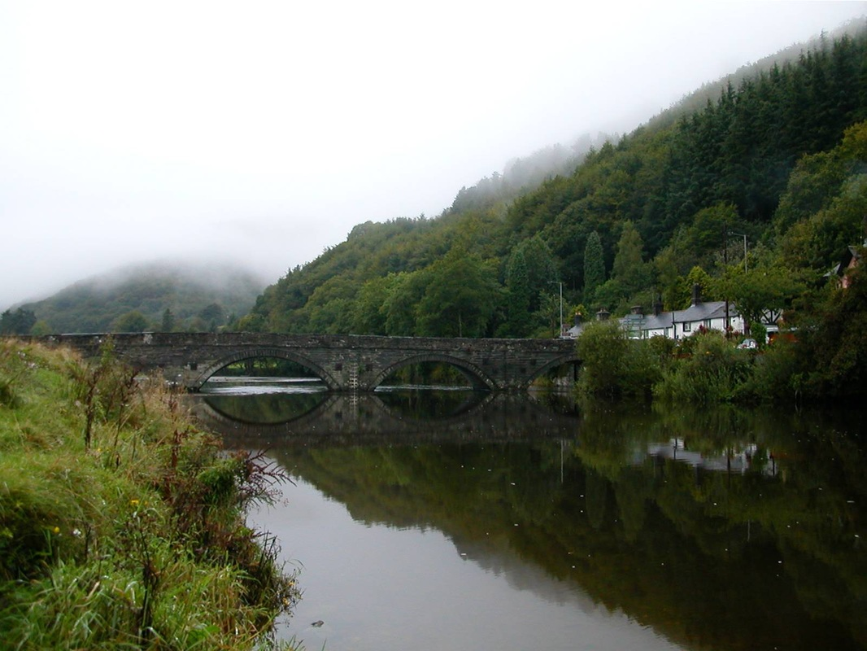****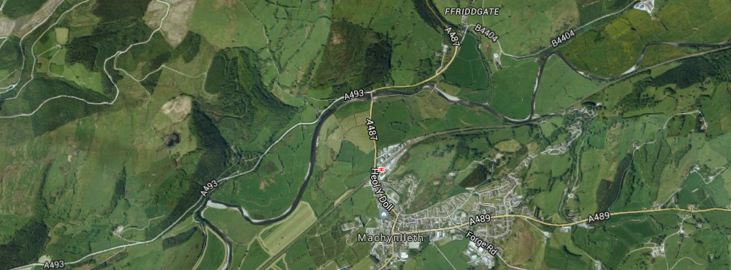

**HOW DOES IT WORK?**

Funding support for the Forestry Hub is a signal of the Welsh Government’s commitment to increasing the range of important benefits which forestry, woodlands and trees provide to people across Wales. The Welsh Government has chosen to support the Forestry Hub in order to bring together organisations with a focus on forestry to work together and share resources, ideas and skills.

The intention is for an office space that becomes established across Wales as a first point of contact for guidance and information on how best to manage and use woodlands for a range of public benefits (Woodlands for People).

Locating organisations in one place provides an opportunity for collaboration. It also provides the chance to develop a critical mass of skills and resources in forestry and woodland expertise which will be useful to public bodies in discharging their duties in relation to woodland management under the Well-Being of Future Generations (Wales) Act 2015.

**Initiatives that are part of the Forestry Hub are expected to contribute to the costs of running the office and to the wider aims of the Forestry Hub.**

For a summary of charges or to discuss

the opportunity to Join the

Hub please contact us.

***Sharing resources and ideas to create a more***

***vibrant and collaborative forestry sector***

***in Wales.***

**FORESTRY HUB**

The office is

***Images:*** *map Google Earth, Dyfi Bridge by Cyril Evans*

**LOCATION**

The Hub is just off the A487 and next to Machynlleth Train Station. There are regular trains between Aberystwyth and Birmingham. By car you can get to Aberystwyth in about 30 mins, Birmingham in 2h20 to, Cardiff in 2h30 and Bangor in 1h45.

**CONTACT**

If you are interested in this opportunity or would like to find out more, please do contact us:

**E:** info@llaisygoedwig.org.uk

**T:** 01654 700061

The Forestry Hub

Llais y Goedwig,

Unit 6, Dyfi Eco Park  
Machynlleth, Powys,

SY20 8AX